

**Subject : MATHEMATICS**

**Grade: 11**

**Total Marks: 25**

**Duration: 30 Minutes**

**Test Date:** Text Box 2, Textbox

**Applicant’s Name:** Text Box 2, Textbox

**Instructions:**

* No Calculators are allowed.
* All questions are compulsory, please use a pen.
* Please circle only one correct answer from the given options.
* Return the question papers and the rough sheets to the invigilator before leaving the hall.
* This document consists of 8 printed pages including this page.

**ATTEMPT THE FOLLOWING**

1.



1. 31
2. 36
3. 37
4. 38

2.

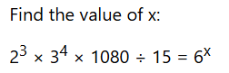

a) 4

b) 6

c) 8

d) 5

3.

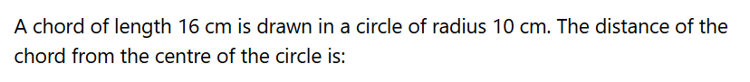

1. 12 cm
2. 8 cm
$$8\sqrt{1}0 cm$$

3. 6 cm

4.



1. 22 cm
2. 14 cm
3. 11 cm
4. 9 cm

5.



1. 36 m
2. 32 m
3. 34 m
4. 30 m

6.



a) 3

b) 2

c) 4

d) 5

7.



$${60}^{o}$$

$${30}^{o}$$

$${45}^{o}$$

$${90}^{o}$$

8.



1. 3 : 1
2. 1 : 3
3. 1 : 2
4. 2 : 1

9.

Two dice are tossed. The probability that the total score is a prime number is:

$$\frac{1}{6}$$

$$\frac{1}{2}$$

$$\frac{5}{12}$$

$$\frac{7}{9}$$

10.

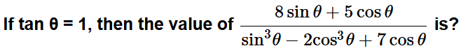

$$2$$

$$2\frac{1}{2}$$

1. 3

$$\frac{4}{5}$$

11.

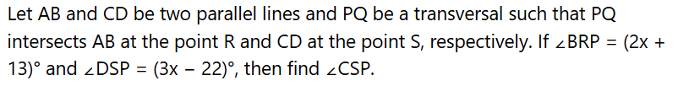

$${97}^{o}$$

$${95}^{o}$$

$${105}^{o}$$

$${83}^{o}$$

12.



1. 77
2. 98
3. 63
4. 49

13.



1. 36 m
2. 34 m
3. 32 m
4. 30 m

14.

1. area (ΔABC) = area (ΔDCQ)
2. area (ΔABC) > area (ΔDCQ)
3. area (ΔABC) < area (ΔDCQ)
4. area (ΔABC) ≠ area (ΔDCQ)

15.

A sphere and a hemisphere have the same volume. The ratio of their curved surface area is:

$$2^{\left(\frac{2}{3}\right)}:1$$

$$2^{\left(\frac{3}{2}\right)}:1$$

$$4^{\left(\frac{2}{3}\right)}:1$$

$$2^{\left(\frac{1}{3}\right)}:1$$

16.



$$−\frac{1}{2}$$

$$\frac{1}{2}$$

$$2$$

$$−2$$

17.



1. (4, 6)
2. (-4, -6)
3. (-4, 6)
4. (4, -6)

18.

A bag contains 2 red, 3 green and 2 blue balls. Two balls are drawn at random. What is the probability that none of the balls drawn is blue?

$$\frac{10}{21}$$

$$\frac{11}{21}$$

$$\frac{2}{7}$$

$$\frac{5}{7}$$

19.

The slant height of a right circular cone is 10 m and its height is 8 m.

Find the area of its curved surface.

$$30π m^{2}$$

$$40π m^{2}$$

$$60π m^{2}$$

$$80π m^{2}$$

20.

A father said to his son, "I was as old as you are at the present at the time of your birth". If the father's age is 38 years now, the son's age five years back was:

1. 14 years
2. 19 years
3. 33 years
4. 38 years

21.

At what rate of compound interest per annum will a sum of Rs. 1200 become Rs. 1348.32 in 2 years?

1. 6%
2. 6.5%
3. 7%
4. 7.5%

22.



1. 36
2. 63
3. 99
4. None of these

23.

A man takes 6 hours 15 minutes in walking a distance and riding back to starting place. He could walk both ways in 7 hours 45 minutes. The time taken by him to ride back both ways is:

a) 4 hours

b) 4 hours 30 min

c) 4 hours 45 min

d) 5 hours

24.



a) $$\sqrt{3}$$

b) $$\frac{1}{\sqrt{3}}$$

c) 1

d) 0

25.

A train covers the first 16 km at a speed of 20 km per hour another 20 km at 40 km per hour and the last 10 km at 15 km per hour. Find the average speed for the entire journey.

1. 24 km
2. 26 km
3. 21 km

$$\frac{1380}{59}$$